Fractals in Music
Bryce Willey
10/04/11

Research on the Subjects of Fractals and Music Theory
This project deals with the relationship between fractals, self-similarity, and music compositions ranging from Baroque Classical, Romantic period, and modern rock. In order to fully understand the results and conclusion of this experiment, one must have a sufficient background knowledge of the above subjects.
A fractal, as defined in the New Shorter Oxford Dictionary, is “a curve having the property that any small part if it, enlarged, has the same statistical character as the whole.” (p. 1017 ,vol. 1, 1993) Take for example, a sierpinski gasket, or triangle
(Figure 1.)
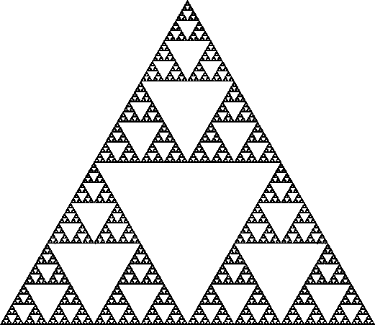(Ho A, 1995).
As you can see, if you were to isolate the top third of this image, it would look almost identical to the original picture. This is called self-similarly. Other well known fractals include the dragon curve, the cantor set, the Hilbert curve, and Koch’s snowflake. All of these display self similarity (Schroeder 1991). However these are only images created by mathematicians. What do they have to do with real life?
Surprisingly, they have almost everything to do with real life. Benoit Mandelbrot, often called the founder of Fractals, gives the following example. Look at any given coastline from space, say the British Isle. If one were to measure it with a ‘ruler’ a kilometer long, one would receive a value of, say, 5,000 meters. However, if one to look closer, it would be noticed that dents within the coast were missed. Go back and measure it again, only with a smaller ruler, a larger value would be received. If this were to be repeated, each time with a smaller measuring device, the coastline would continue to increase in length. This idea of infinite perimeter within a finite area is the basis of many fractals.
Now on to music theory. The basics of music theory include pitch, or wavelength in scientific terms, duration, dynamics, or amplitude, harmony, and the tone color, or waveform. There are three main periods of music and one genre that will be analyzed in this experiment; they include Baroque and Classical, Romantic, Modern, and Rock ‘n Roll. The Baroque and Classical period, which lasted from the early seventeenth century until the early nineteenth century, is actually two different musically periods, but for the purposes of this experiment, are combined into one. They are characterized by well defined melodies and instrument color. Well-known composers of the time were Bach, Mozart, Beethoven, Haydn, and Handel. The Romantic period lasted throughout the nineteenth century and has also been called impressionism, due to its innovating principals of earlier periods. Composers of this period included Debussy, Chopin, Grieg, and Brahms. Modern is from the beginning of the twentieth century until now. Music in this period has been so widespread in composure and technique that there are really no boundaries on it, beside the date it was written (Classical Net, 2011). Rock ‘n Roll began in the 1950’s with Chuck Berry, Elvis Presley, and the Beatles. It usually had a series of defined blues chords of which it was based, but it evolved into much more complex melodies and rhythms.
Intervals are the differences between two pitches, and are measured as 1st, 2nd, 3rd, and up to a 12th for an octave. In “The Self-similarity of the ‘1/f noise’ called music”, J. S. Bach’s Invention no. 1 is analyzed for the same values as discussed in the coastline problem above. The total number of notes was reduced from all of the notes, to ½ of the total, to ¼, etc, and the absolute values of all the intervals amongst those notes were added. The results were that as the number of notes decreased, so did the total number of intervals, in a near linear fashion (Kenneth J. Hsü and Andrew Hsü, 1990). The function, (1/2) ^ε, is also called a power function. The Hsü’s also analyzed the graphs of the acoustic frequencies of each note plotted by time. They found that when they reduced the number of notes to ½, ¼, etc, the graphs had similar curves and shapes compared to those with more or less notes. This is a perfect example of self-similarity.
The above topics are all relevant to the following experiment, and lay the foundation for basic understanding of the concepts of this experiment. The creator of this experiment has plentiful experience in music theory, composition, and performance, and has an understanding above the level of amateur in that of fractals.
References
Brown L, editor; 1993. The new shorter Oxford dictionary. New York: Oxford University Press.
c1995 [updated 2011 July; cited 2011 Oct 3]. Classical Net [Internet]. United States: Classical Net; Available from: http://www.classical.net/music/history.php
Ho A; 1995. Sierpinski triangle [Internet]. [Place unknown]; c1995 [cited 2011 Oct 2]. Available from: http://www.zeuscat.com/andrew/chaos/sierpinski.html
Hsü K, Hsü A. 1990 July 27 [cited 2011 Oct 2]. Self-similarity of the “1/f noise” called music. Proc. Natl. Acad. Sci. USA. [Internet]; 88: 3507-3509. Available from: http://www.ncbi.nlm.nih.gov/pmc/articles/PMC51477/pdf/pnas01058-0549.pdf
O’Brien J [date unknown]. Fractals and Their Use in Music [Internet]. [Place unknown]: Comm 141; Available from: http://www.unc.edu/~jimlee/JohnObrienFractalMusic.htm
Schroeder M; 1991. Fractals, chaos, power laws: minutes from an infinite paradise. Mineola (NY): Dover Publications.

